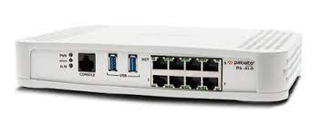

**PALO ALTO REMOTE ACCESS CLIENTLESS SSL**

****Brendon Ahn | Cybersecurity | 2022-2023

**Purpose:**

To set up Clientless SSL to access a webserver on a remote desktop

**Background:**

Remote Access Clientless SSL VPN allows user to remotely access webservers of any machine on the network. SSL stands for Secure Sockets Layer, which allows secure remote access to web browsers. It uses end-to-end encryption to better secure the traffic between devices when connecting through remote access.

SSL VPNS can be used on all the top operating systems making it a very flexible method of remote access. This is really good for businesses that use many different type of operating systems. In our lab we did it with Windows. With Clientless SSL VPN on palo alto you can control policies and resource management. This creates stronger security, and you can also record the information of those connecting and when. Additionally on the palo alto you can do security checks before granting access.

We had to use apachex to make a local webserver and were able to connect to it using remote access from another machine as we were on the same network. For a company you can securely access and local webserver from any location on the network which is very beneficial for a lot of tasks, such as accessing sensitive employee information and other private details that you want to keep from mal intentioned people.

The set up for Clientless SSL VPNs are pretty simple. If you did the global protect configurations all you need is minor adjustments to those configs and then you just need to configure the Clientless SSL configurations on the Palo Altos.

**Lab Summary:**

We configured Remote Access Clientless SSL VPNs on Palo Alto 410s to remotely access a local webserver.

**Lab Procedure:**

Step 1: Follow the configuration guide for global protect, these configs are additional configurations to do on top of that

Step 2: Install the GlobalProtect Clientless VPN

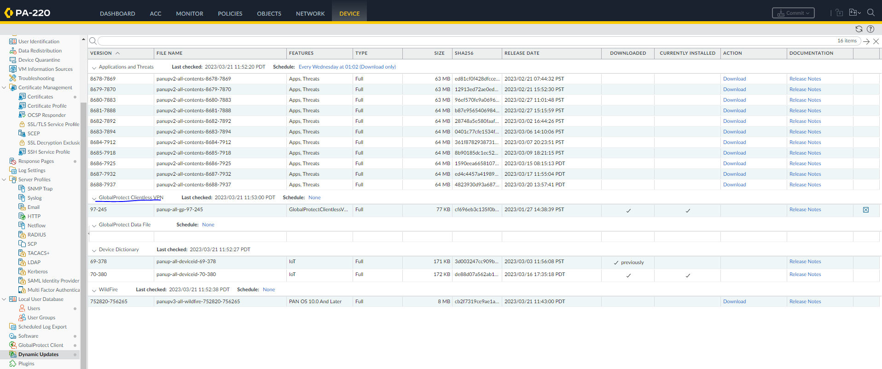

Step 5: Go to portals and configure the following

Step 7: go to Clientless VPN and configure the following

Step 9: go to Crypto Settings and configure the following

Step 10: create a clientless application

Step 11: Set up a DNS Proxy

Step 12: Configure User Mapping

Set up user mapping

If you haven’t already, to do this you need to set up a local webserver using Apache or some other application.

**Problems:**

Initially we didn’t know we needed a local webserver for the lab. We had to learn a little bit of HTML and download Apache. Majority of the configs went really smooth though we did forget a few of the commands. The loading was kind of slow, so we looked for problems that didn’t exist when our user and password weren’t giving us access to the Palo Alto page, but it was just that it took a few minutes for changes to process over the web. We also forgot to connect to the right ports at times which was a layer 1 issue but an issue, nonetheless. Overall, this lab only took 2 days to finish, so it was relatively fast.

**Conclusion:**

We successfully configure remote access clientless vpns onto our palo alto 410s to securely remotely access a local webserver on a another machine.